Shabbos Stories For
parshas vayeitzei 5785
Volume 16, Issue 11 6 Kislev 5785/December 7, 2024
Printed L’illuy nishmas Nechama bas R’ Noach, a”h
For a free subscription, please forward your request to keren18@juno.com
Past emails can be found on the website – ShabbosStories.com

Precious: More than Gold



It was 1951, and young Yitzchak walked along the streets of Yerushalayim on a spring Shabbos afternoon, returning home after his weekly Tehillim group. As Yitzchak turned onto a quiet narrow street, his eye caught the glare of the sun shining off something lying on the ground. As he came closer, he saw that it was a gold coin. What should he do? The coin could help his family for the next few weeks. The poverty at that time was rampant; a typical Shabbos seudah consisted of two challos, a slice of fish, and some rice.
But Yitzchak stopped; it was Shabbos Kodesh. He was not permitted to take the coin. Yitzchak Eisenbach remembered that although he could not move the coin, he was allowed to stand over the coin without shifting it. He placed his feet on the coin and was planning to wait the two remaining hours until Shabbos was over and then take the coin for himself.
From the window of his apartment, a young Arab was observing the scene and wondering why a Jewish boy was standing in the same spot for twenty minutes. He came outside and noticed the radiating glow. He then walked up to Yitzchak, pushed him over, took the precious coin, and walked off.
Yitzchak laid there helpless against the Arab’s attack, and after he left, Yitzchak cried his way home. When he came home, his father asked him what happened, and Yitzchak told his father the whole story — how he’d found a gold coin, how he’d planned to stand on it till Shabbos ended, and how the Arab had pushed him and took away the precious coin. His father tried to comfort him but to no avail. Yitzchak was disappointed.



On Motzaei Shabbos, when Maariv ended, the great tzaddik and gaon, Rav Weidenfeld, zt”l, known as the Tchebiner Rav, called Yitzchak over and asked him why he was sad. When Yitzchak told the Rav what occurred, the Rav looked at Yitzchak and said, “Ask your father if he lets you come to my house. There’s something I want to tell you.” After getting permission, Yitzchak walked home with the great tzaddik.
“Yitzchak,” the Rav started, “you lost a gold coin today, and you must be very sad. I have a gold coin in my drawer, and I’m willing to give it to you, but on one condition.”
Yitzchak’s eyes perked in disbelief. “What’s the condition?”
The Rav smiled and said, “On the condition that you grant me the reward of the mitzva you’ve done. You got one of the biggest mitzvos possible; you held yourself back from moving muktze by not taking the gold coin. That mitzva is so great, and I eagerly desire it for myself. If you give me the zechus, then I’ll give you that gold coin.”
When Yitzchak heard the Rav’s words, he came to the realization that although he didn’t have a gold coin, he had something far more precious than money could buy. He had acquired the great mitzva of guarding Shabbos, and that was priceless. He then looked at the Rav and said, “I would rather not give that away.”
The Rav patted him on the forehead and wished him “Gutta vach.” Yitzchak skipped home realizing how much he’d gained with his precious “find.”

Reprinted from the Parshas Noach 5785 email of Zichru Toras Moshe
The Reward



Once upon a time there lived a very charitable man.
One day - it was Hoshana Rabbah-- his wife gave him ten shekels and asked him to go and buy something for their children. At that moment a collection was being made in the market place for a poor orphaned girl who was about to be married. When the collectors saw this charitable person they said, "Here comes a very charitable man." They addressed themselves to him saying, "Will you take a share in this worthy cause, for we want to buy a present for the poor bride?"
The good man gave them all the ten Shekels he had. Now he was ashamed to return home empty handed, and so he went to the synagogue. There he found children playing with etrogim, for it was Hoshana Rabba (the seventh day of Sukkot) and there was no more need for the etrogim. The good man collected a sack full of etrogim and went out to seek his fortune.
Arriving in a strange land he sat down on his sack of etrogim, wondering what he was going to do next. Suddenly he was approached by the king's officers, who asked him what he had in that sack.
"I am a poor man and have nothing to sell," he replied. They opened his sack and found it was full of etrogim.
"What kind of fruit is this?" the officers asked. "These are etrogim, a special fruit used by Jews during their festival of Sukkot."
When the officers heard that, they grabbed him and his sack and carried him all the way to the palace. It was then that our good man learned what all the excitement was about:
The king was very ill and he was told that only the fruit used by Jews during their festival of Sukkot could cure him. A very intensive search had yielded nothing, and just when all hope seemed to be gone, this good man arrived with a sack full of etrogim, and thus saved the king's life.
The king recovered his health and ordered the sack emptied of the etrogim to be filled with golden dinars. Our good man now returned home richly rewarded for the charity he had been giving all his life.

Reprinted from the Sukkos 5784 email of Chabad.Org Magazine.

In the Merit of One Shidduch
By Rabbi David Ashear

Rabbi Friedman received a phone call from a shadchan who suggested a shidduch for his son. It sounded like an excellent idea, and he hoped the other side would feel the same way. Right after that phone conversation he went to shul, where a man from Eretz Yisrael approached him to unburden himself and ask for chizuk. He told Rabbi Friedman that his 23-year-old daughter had been widowed and was raising a two-year-old daughter.
The rabbi commiserated with him and gave him chizuk. A few minutes later, he had a brainstorm. He suddenly remembered a young rabbinical scholar with excellent middos who lived in Bnei Brak. Tragically, his wife had passed away a few months earlier, leaving him with a six-year-old daughter to raise. Perhaps this could be a match?
Rabbi Friedman looked around the shul. Thankfully, the Israeli man was still there. He told him about the young widower, and then called the young rabbi in Bnei Brak and gave him information about the widow. Over the next week, there was a lot of back-and-forth regarding his son’s shidduch, as well as the shidduch he had suggested.
About a week later, the widow’s father called to say they were interested in proceeding, but first he wanted to meet the young man. As hashgachah would have it, the young man was coming to the USA from Eretz Yisrael for a different reason that Sunday. The father met him, and everyone decided to proceed with the shidduch.
That very same day, Rabbi Friedman received a call from the shadchan saying that the other side was agreeable to move forward with his son. From that point on, the two shidduchim progressed in tandem. The widow and widower became engaged on a Wednesday night, and the very next night, Rabbi Friedman’s son followed suit.
The rabbi saw so clearly how Hashem had given him the opportunity to make a shidduch at the very time he was hoping to find a kallah for his son. It was an exceptional merit for him to bring such a couple together, to find a mother for a bereaved six-year-old girl and a father for a two-year-old. From Lakewood, NJ, Rabbi Friedman was able to make a shidduch between two people who lived in Eretz Yisrael! The rabbi was appreciative that his act of chessed gave him the merit for his son’s shidduch to progress smoothly. (Excerpted from the ArtScroll book – “Living Emunah on Shidduchim”)

Reprinted from the Parshas Noach 5785 email of The Weekly Vort.

Deal of a Lifetime!
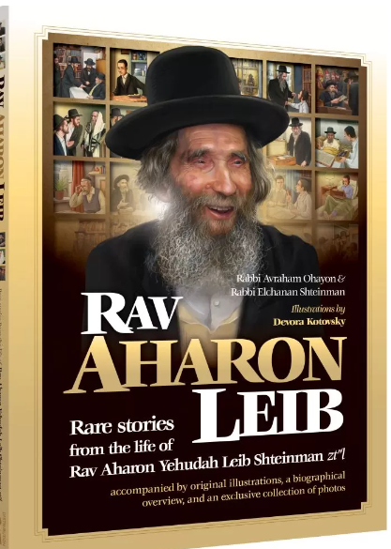

One of the old neighbors of Rav Aharon Leib Shteinman, zt”l, was Rav Lipa Yisraelsohn. Before Rav Lipa would travel to New York, he’d come to Rav Aharon Leib to receive the rosh yeshiva’s beracha for hatzlacha. One time, however, he was in for a surprise. Rav Aharon Leib lifted his eyes and said, “Rav Lipa, since you’re going to America, I’ll make a deal with you!”
Before Rav Lipa could inquire as to the type of business Rav Aharon Leib was interested in making, Rav Aharon Leib told him that the deal was indeed serious — one that Rav Lipa stood to potentially make one million dollars!
“During your travels to America, you’ll meet up with many wealthy people. If you meet one of them who’s as wealthy as I am, I’ll give you a million dollars cash.”
Rav Aharon Leib stood up from his seat, took Rav Lipa by the hand, and proceeded to walk him around the house. Rav Aharon Leib stopped next to the refrigerator, opened its door, and pointed to the many items inside. “Tell me please, Rav Lipa, is there anything missing here? B’chasdei Hashem, there’s plenty of food here — food for during the week, food for Shabbos, etc. Baruch Hashem, we’re not lacking anything!”

Only the Rich People Could Eat Chicken on Shabbos
Rav Aharon Leib’s younger years in Lithuania were times of serious poverty. He once mentioned to a relative of his that they used to say that only the rich people could eat chicken on Shabbos, and only one known wealthy person, Zev Visosky, ate chicken even during the week! If so, they’d joke, what did he eat for Shabbos? Fruit compote! “But my fridge,” quipped Rav Aharon Leib, “has fruit compote all the time. See, then, how I’m the richest man in the world!”
Rav Aharon Leib continued his tour by opening his closet. “Look at how much clothing I have — weekday clothes, Shabbos clothes, clothes for winter, and clothes for summer. In gashmiyus, I’m not lacking anything, and in ruchniyus, I try to do what’s required of me. So, if you’re able to find someone better off than me, you’ll be a million dollars richer!”

Looking for that One Yid in America
Who is Richer that Rav Aharon Leib
Rav Lipa got on the plane with Rav Aharon Leib’s words ringing in his ears. He decided to search out and find if there really is a Yid in America richer than Rav Aharon Leib. Sure enough, he went around and met many wealthy people — millionaires and even billionaires — but none of them could testify that he was happy or content with his lot.
One told Rav Lipa how every time he earns a million dollars, he’s pained that he didn’t work harder and bring in two. Another revealed how his life is nothing but worry and fear — to the point that his young son needed an armed guard to escort him to school lest he get kidnapped for ransom! Every wealthy philanthropist he met complained about the tremendous yoke he carried on his shoulders, about the headaches, the ungratefulness, and the constant pressures that filled his life.
On the course of his trip, Rav Lipa came to one person’s mansion that was so big that Rav Lipa had to drive six minutes from the front gate just to get to the man’s office. In the middle of the meeting, the gvir turned to Rav Lipa and said, “If you promise me a month of peace and serenity, I’ll write you a check for three million dollars!”
On his flight back to Eretz Yisrael, one millionaire confided to Rav Lipa: “All my friends only care about my money. I’m alone without any companions. I can’t trust anyone, not even my close family. All of them only honor and flatter me just because of their personal interests. Nobody in the world sincerely cares about me.”
Throughout his journey, Rav Lipa thought to himself, “How can I tell these wealthy people that in Bnei Brak, on 5 Rechov Chazon Ish, in an old, dilapidated house, there’s a happy Yid who’s richer than any of them?” Nowhere in Rav Lipa’s travels did he meet anyone as wealthy as Rav Aharon Leib, and thus he resigned that he wouldn’t be getting his promised million dollars. However, he did ask Rav Aharon Leib if, when he traveled again to New York, if the deal was still “live,” and the rosh yeshiva agreed.

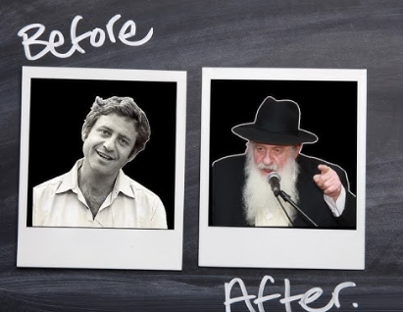
Rav Uri Zohar before and after he
became Israel’s most famous baal teshuvah

On that second trip to New York, Rav Lipa ran into Rav Uri Zohar, who was one of the previous generations best known mezakei rabim. Rav Lipa told Rav Uri all about the deal he’d made with Rav Aharon Leib to find someone richer than the rosh yeshiva.
After a few moments, Rav Uri happily announced, “Rav Lipa, you’ve just won the ‘lotto!’ You can return to Rav Aharon Leib and tell him that you met someone richer than him. He was never part of the ‘outside world,’ but I came from there, and therefore I know how much richer I am. I know how much meaning and purpose lays in a Torah life verses the empty joy that occupies the “outside world.” Coming from there make me wealthier than Rav Aharon Leib!”
The two then jokingly quibbled over how much percentage Rav Uri should get for helping Rav Lipa to his million dollars. Before they parted, though, Rav Uri turned to Rav Lipa and said, “You know what? I think I might be wrong. Go back and tell Rav Aharon Leib that while I originally thought I was the wealthier one, I’ve changed my mind and think that he’s the richer one.
“I’ll tell you why: Every time I come into Rav Aharon Leib’s house, whatever hour it may be, I see the rosh yeshiva sitting in the same position — his body upright, his tzitzis upon him, his hat on his head, and a pillow behind his head to prop him up. Where in the entire world would you find someone who sits like that even when nobody is around? Only someone who lives with a constant awareness of Hashem’s presence. That person is the richest man in the world, and there’s nobody more content than him anywhere on the globe.”
When Rav Lipa returned to Eretz Yisrael, he admitted to Rav Aharon Leib that he hadn’t found anyone as wealthy as the rosh yeshiva.

Reprinted from the Parshas Noach 5785 email of Zichru Toras Moshe

Learning from Animals
By Aharon Spetner
Illustrated by Miri Weinreb

“Totty,” said Moishy from the back seat of the car. “Why are we stopping?”
“I’m not sure what’s going on,” Totty replied. “It looks like they closed the entire Delmar Boulevard. I guess we’ll have to go around.”
“Why does it smell like animals?” asked Dovid. “It reminds me of when we went to that farm on Chol Hamo’ed.”
“That is a very good question.” Totty said. “I smell it too.”
Just then the Friedmans heard what sounded like the roar of a lion.
“Let’s go check and see what’s happening,” Totty said. “It sounds exciting!”
Totty parked the car and as they all got out and started walking towards the commotion, the smell of animals grew unmistakably stronger.
“Look, Totty!” said Dovid. “There’s a huge crowd of people by City Hall!”
As they got closer they saw that there were indeed many animals in front of City Hall - and the mayor was standing at a podium in the middle! It looked like most of the animals were in the kind of train that one would usually find in a zoo. “Has the mayor lost his mind?” asked Moishy, bewildered. “There’s a loose crocodile on top of that train!”

“We’d better not get too close,” said Totty.” It doesn’t look like any of the animals are on leashes or in cages.”



Just then, Mayor McGillicuddy’s voice came over the loudspeakers that had been set up. “My dear residents of University City,” he began. “It is my great pleasure to announce to you the inauguration of the new University City Zoo that we will be building on Alfred Avenue, off of Woodson Road.”
The mayor puffed out his chest importantly. “I have managed to get these animals donated from the president herself. What an honor to be able to give these gentle animals a new home right here in our city!” he exclaimed to wild cheers from the crowd, while one of the gorillas climbed out of the train and broke a street lamp in half.
“We’d better move further back,” Totty wisely told his boys. “It looks like that rhinoceros is about to jump out of the train.”
The Friedmans backed away from the wild scene as the mayor continued to speak about how he thought it was such a brilliant idea to use the new Zoo Train to bring all of the animals to their new home.
“Don’t worry that we haven’t built any cages yet!” the mayor shouted joyfully. “We have told the animals that they must behave until we finish building the zoo! Everyone is safe!”
The boys hurried after Totty to the car so they could get as far away from the madness as possible. As they drove away, Totty said “boys, you know what we just saw is an important reminder of how great Tzadikim are.”

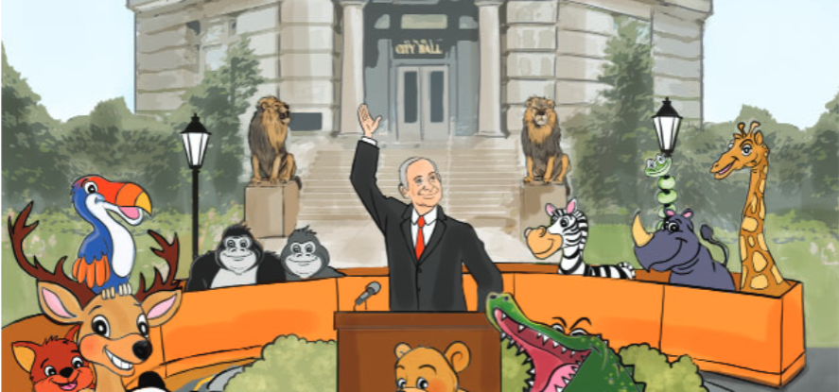

“The mayor is a Tzadik?” Dovid asked. “He doesn’t seem like one.”
“No, no,” laughed Totty. “I’m talking about what the animals remind us of. All of the animals in the world today only exist because of Noach the tzadik! If not for Noach there wouldn’t be any animals! In the zchus of Noach, the world and the animals were saved from the mabul.
“And that’s a lesson for us about how important tzadikim are. Don’t make a mistake and think that tzadikim are just to give brachos or to be on gedolim pictures. The tzadikim are the ones who keep the world in existence – just like Noach did in his days. And that means that every time we see animals, whether it’s on a trip to a farm, a squirrel climbing a tree, or passing by City Hall, it’s an important reminder that this world and everything in it exists solely because of the zchus of the Tzadikim in every generation. They are the ones whose Torah and Mitzvos keep the world going.”
“Totty,” said Moishy. “Should we go on a trip to the zoo every day so that we remember this lesson?”
Totty smiled. “I don’t know about every day,” he said. “And we definitely want to wait until they build some cages for the wild animals. “But Moishy, we don’t need to go to the zoo to learn this lesson. We can even learn it when we look in the mirror.”
“If not for the tzidkus of Noach, you and I wouldn’t be here today either, because there would be no people in the world! When you wake up in the morning and look at your hands and feet, after thanking Hashem for giving you such an amazing body, remember that everything we have is because of Noach Hatzadik and the other tzadikim in all the generations – even today – who serve Hashem every minute of their lives. That’s a very important lesson to remember. It’s only in the zchus of the tzadikim that the world continues to exist!”

Reprinted from the Parshas Noach 5785 email of Toras Avigdor Junior based on the Torah teachings of Rav Avigdor Miller, zt”l.

Twin Calves From/
For a Blessing
From the Desk of Yerachmiel Tilles

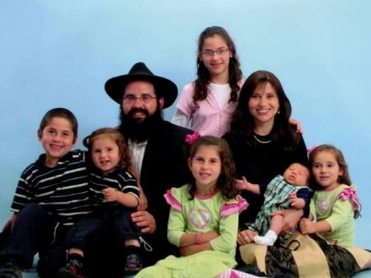

(Story #1)
Years ago, my wife Rochi (Rachel) and I [Yechiel-Shlomo Levitansky] were set to go on shlichus to Sumy, a small city in northern Ukraine, near the Russian border. [1] When we arrived, my family stayed with the shluchim (emissaries) in Kharkov [a 3-hour ride southeast from Sumy], while I went to Sumy to search for an apartment.
One night, I walked to my hotel room feeling very down. I had been there for two weeks already, but I had not yet found a suitable place for us to live. Was this all one big mistake?
The town square was mostly deserted. Over and over again, I replayed the events of the past two weeks in my mind. Packing up our apartment in California and shipping everything away. Flying with my wife and three children across the ocean. Spending weeks looking for a suitable home to live in; half of the buildings didn’t even have running water or a bathroom.
Heavy footsteps interrupted my thoughts. I looked up to find a Ukrainian man walking straight towards me. It was dark, and this man was staring at me. I got a little nervous. “Good evening,” I called out in Russian.
“Good evening,” he replied. “Are you Chabad Lubavitch?”
I blinked. This was not what I expected to hear! “Yes,” I stammered. “Who are you?”
“I’m also Chabad Lubavitch!”
I looked the heavyset Ukrainian up and down. Him, a Lubavitcher? “Are you Jewish?” I asked.
“No.”
“So! how does that work?” I asked delicately. “You’re not Jewish, but you’re Chabad Lubavitch?”
“I work for the Lubavicher Rebbe!” He said proudly.
The Rebbe? I knew that in Ukraine, people refer to their Rabbis as ‘Rebbe’. Maybe he works for a shliach in a neighboring city?
“No, no, no!” he said. “I work for Rabbi Shneerson himself!”
My eyes opened wide.
“A few years ago, I won a lottery for an American green card,” he explained. “When I went to live in Brooklyn, I worked for the Rebbe! For three years, I was the janitor at the Ohel in Queens! I know all the rabbis there - Rabbi Refson, Rabbi Krinsky - if you want, you can ask them about me!”
I was stunned. What were the odds? Just moments before, I was doubting my decision to go on shlichus in such a remote location. And right then, in the remote town of Sumy, Ukraine, Hashem (G-d) showed me that He knew exactly where I was and that He was with me! How else could I explain my encounter with a Ukrainian gentile who so proudly called himself a Lubavitcher?
And if this Ukrainian man, who was the janitor at the Ohel, could walk around proudly, saying that he works for the Lubavitcher Rebbe, where was my own pride? I was a shliach of the Rebbe!
All my doubts disappeared. I straightened my shoulders and continued walking to my hotel room, ready to build my future in this city no matter what it took. The next day, I found an apartment.
Who would have ever imagined that a little city in Ukraine would have a shul with a minyan and daily kollel (yeshiva-style learning for married men), weekly classes for women and a beautiful mikvah? Little did the Jews of Sumy, Ukraine know, but their lives were about to be changed forever.
(Story #2)
Each month, I go to the farm to watch the cows being milked so I can bring home fresh cholov yisroel (Jewish supervised) milk for my family. When we first arrived here, though, it wasn’t so simple. I needed fresh milk for my baby, so I went around asking the nearby farmers if I could watch them milk their cows.
To my dismay, they all refused! Apparently, they had this tradition that if a stranger watches a cow being milked, the cow will die! I offered to pay a lot of money, but they didn’t budge. Finally, I found an old couple who once had Jewish neighbors, so they were familiar with the concept.
I would come at 5 am, watch them milk their one and only cow for an hour, and return home with three liters of milk. One week, they told me that their cow was pregnant and would stop giving milk, so I should come every day to stock up.
When the cow finally gave birth, it had twins! The couple was ecstatic, they could sell one of the calves for a half a year’s salary!
It was the talk of the town that "the rabbi blessed the cow". From then on, all the farmers were eager to let me watch them milk their cows in the hopes that their cows might be blessed as well!
(Story #3)
Let me conclude with a story that might give you an even bigger laugh.
For the first few years of our shlichus, we had to renew our visa very often. The rules constantly changed, and it was a big headache. I hired a lawyer to figure it out for me, and eventually, he told me that I should try applying for residency.
Two weeks after I submitted my application, I was called to the immigration office. I was told that while my application was denied, the head of immigration wanted to speak with me.
“I’ll be honest with you,” she told me. “I’m not convinced by your story. You brought your entire family from California to life in the small town of Sumy, Ukraine. The only logical reason I can see for you to do that is either because you’re a spy, or because you’re not normal! And we don’t need spies nor crazy people here. So, I have to deny your application.”
I couldn’t believe my ears! There I had it: an official government stamp that my going on shlichus to Ukraine was crazy. And that’s exactly what the Rebbe wanted from us! Not to go on shlichus because it makes sense, but because of shtus d’kedusha (“holy craziness”), an unexplainable desire to brighten up the world for the better!

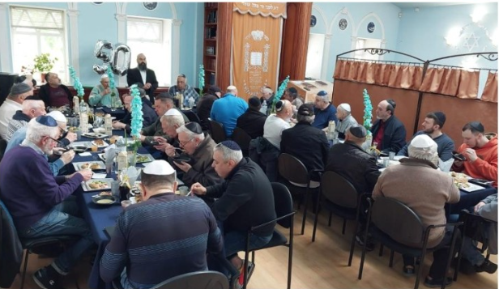
Jewish life with Chabad in Sumy, Ukraine
I left the office on a high, ready to conquer the world.
In the end, we got our residency. My wife gave birth to our two younger daughters in Ukraine, which gave us an official legitimate reason for permanent residency. But I will never forget the lesson I learned in that little government office: logic and reason cannot stand in the way of making the world a better place and bringing Moshiach.
~~~~~~~~~~~~~~~~
Source: Extracted, copy edited and supplemented by Yerachmiel Tilles from a report on //dollardaily.org. [“Dollar Daily” is a creative tzadaka project to benefit Chabad shluchim families.]
Why this week? All the animals came to Noah’s Ark in pairs.

[1] Yechiel Slomo Levitansky lives at present in Sumy, Ukraine with his wife Rachel and their six children. After serving as a rabbi in Los Angeles (where he was born in 1974,) and South Africa (where she was born) he moved to Ukraine to the city of Sumy to be the chief rabbi. His shlichut is the restoration of Jewish life in Sumy and the Sumy region. [from the fjc.org.ua website]

Reprinted from the Parashat Noach 5785 email of KabbalahOnline.org, a project of Ascent of Safed in Israel.

